IIHT

Time To Complete: 10 to 12 hr

Political Parties Application

Contents

1 Problem Statement 2

2 Proposed Political Party Application Wireframe 2

3 Tool Chain 3

4 Business Requirements: 4

5 Proposed Rest Endpoints to be exposed 7

5.1 Rest APIs: 7

6 Rubrics/Expected Deliverables 7

7 Implementation/Functional Requirements 8

7.1 Product and Frameworks: 8

7.2 Governance and Tooling: 9

7.3 Code Quality/Optimizations 9

8 Platform 9

8.1 Cloud Specific Design 9

8.2 Design Specification - 1 9

8.3 Design specification - 2 9

8.4 Design specification – 3 10

9 Methodology 10

9.1 Agile 10

# Problem Statement

**Political Party Application** is Restful Application. The Main purpose of Political is to register the party and register all the political leaders belongs to the specific party. This application also maintains the development work assigned to the candidates in their areas. The core modules of Political Party app are:

* Register Political party
* Register the political leaders to their parties
* Assign development works to specific political leaders
* Enlisting all the development work assigned to a political leader

The scope includes developing the application using tool chain mentioned below.

# Proposed Political Party Application Wireframe

Below is the wireframe for reference.

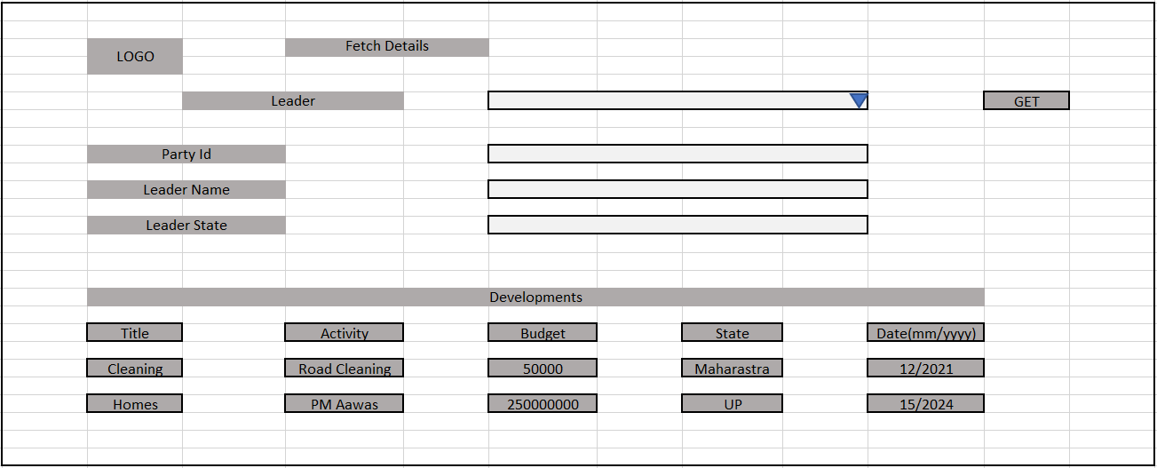

# Tool Chain

|  |  |  |
| --- | --- | --- |
| Competency | Skill | Skill Detail |
| Engineering Mindset | Code Quality |  |
|  |  |  |
| Programming Languages | Application Language | Java |
| Products & Frameworks | Presentation | Angular/React |
|  |  | Javascript/Typescript |
|  |  | Bootstrap |
|  | Compute & Integration | Spring Boot |
|  |  |  |
|  | Governance & Tooling | JUnit |
|  |  | Mockito |
|  |  | Jasmine |
|  |  | JaCoCo |
|  |  | SonarQube |

# Business Requirements:

Below are the user stories for the given problem statement

|  |  |  |  |
| --- | --- | --- | --- |
| **User**  **Story #** | **User Story Name** | **User Story** | **Development** |
| US_01 | Political Leader Functionalities | As a Political Leader I can register myself with a Party  *While registering for a Party, following information is required.*   * Party Id * Leader Name * Leader State   It also requires Party information as follows:  Party Information   * Party Name * Founder name * Foundation Year   Constraints:   1. Political Party should be already existing 2. Foundation year should be a Number   Validations:   1. Party id is not null, and is a number 2. Leader name is not null, min 5 and max 100 characters. 3. Leader state is not null, min 5 and max 100 characters. 4. Party name is not null, min 5 and max 100 characters 5. Founder name is not null, min 5 and max 100 characters | Only API to be developed |
| US_02 | Party Functionalities | As a Party I can delete a Political Leader registered with party  Constraints:   1. If Political Leader is tried to be deleted which does not exist, it must throw a custom exception. 2. When Party is trying to delete the Leader, the party should exist otherwise, throw a custom exception. | Only API to be developed |
| US_03 | Development Functionalities | As a Political Leader, some development work is to be assigned to me.  *While assigning the development work, following information is required from the Political Leader.*   * Political Leader Id * Development title * Activity * Budget * State * Activity Month * Activity Year   Precondition:   1. Leader Id must be of an existing Political Leader available for development activity (Can get from Database)   Constraints:   1. More than one activity can be allocated to a single Political Leader   Validations:   1. Political Leader is not null 2. Development title is not null, min 5 and max 100 characters. 3. Activity is not null, min 5 and max 100 characters. 4. Budget is a number in max 2 decimal points 5. State is not null, min 3 and max 50 characters 6. Activity Year is a number and in the Range of 2020 to 2040. 7. Activity month is a number and in the range of 1 to 12. | Only API to be developed |
| US_04 | Political Leader functionality | As a Political Leader I can list all the development works assigned to me.  Considerations:   1. While fetching the above details the API must return the development details (title, activity, state, budget, year and month) along with the Leader details 2. Development details must be in descending order of activity year. | API and Frontend to be developed |
| US_05 | Political Leader functionality | As a Political Leader I am able to update the development works assigned to me.  Constraints:   1. If the development id does not exist, it must throw a custom exception | Only API to be developed |

# Proposed Rest Endpoints to be exposed

## Rest APIs:

|  |  |  |  |  |  |  |  |  |
| --- | --- | --- | --- | --- | --- | --- | --- | --- |
| |  |  | | --- | --- | | **URL Exposed** | **Purpose** | | /politics/api/v1/leader/register-leader | Adds a Leader in a Party | | / politics/api/v1/party/delete/{leaderId} | Delete a Political leader from the Party | | /politics/api/v1/development/add-development | Assign a Development work to a Political Leader | |
| |  |  | | --- | --- | | **URL Exposed** | **Purpose** | | /politics/api/v1/development/get-development-by-{leaderId} | Get all the development tasks assigned to a Political Leader | | / politics/api/v1/development/update-development | Update the development | |

# Implementation/Functional Requirements

## Product and Frameworks:

1. **Presentation**

Develop the frontend for User Story 4. (Implementation as follows)

1. Implement using either Angular or React.
2. Implement any one of the Gang of four Patterns to compose data using typescript before presenting the same on UI.
3. Implement at least one approach for UI performance consideration.
4. Identify and Implement client-side Optimization Techniques for Bootstrap.
5. **Compute and Integration**

Develop the backend application as a RESTful Application. (Implementation as follows)

* + 1. Use any one of the Creational Design patterns for composing the model object to be sent back as response on following endpoint:

/ politics/api/v1/parties/get/all

(Fetches details of all the parties registered)

* + 1. Optimize you REST endpoints to allow filtering, sorting, and pagination.

## Governance and Tooling:

* + - 1. Follow the practise of Creating Testable Component
      2. Configure your frontend application to implement Unit Testing using Jasmin & Karma.
      3. Configure your backend application to implement Unit Testing using Junit and Mockito.
      4. Test suites must contain exception situation testing.
      5. Generate the Code Coverage report of the same.
      6. Generate the Code Quality Report of the backend application.

## Code Quality/Optimizations

1. Associates should have written clean code that is readable.
2. Associates need to follow SOLID programming principles.
3. Generate the code quality report of the same.